Employee Compensation Compliance
Project Statement Effort Coordinator
Guide
November 2021

Table of Contents
Table of Contents 2
Overview 4
Accessing ECC 4
The Effort Coordinator Role in ECC 4
The PI Confirmation Process 5
ECC Project Statement Status 6
The Work List 6
Statements Awaiting Confirmation 6
Coordinator Tasks 6
Project Statements 7
Managing Project Statements 7
Finding a Project Statement 7
The Project Statement Page 8
Work List Summary Pane 8
Statement Information Pane 9
Project Statement Pane 9
Project Statement Revision 12
Process Project Statement Revision 14
Reports and Resources 16
Calendar Year Effort View 16
Institutional Base Salary Payroll 17
Other Dashboard Reports 18
Expiring Accounts with Labor 18
Salary Charged to Grants 18
Labor on Continuation Accounts 18
Reports within ECC 19
Parameter Options 19
Project Status Report 20
PI and Staff Payroll Report 20
Sponsored Project Employee Summary (SPES) Report 22
Appendix A: Maintenance of Effort Coordinators 23
To Add an Effort Coordinator 23
To Change an Effort Coordinator 23
Changing Primary Effort Coordinators 23
To Remove an Effort Coordinator 23
Appendix B: Project Workflow Statuses 25
Appendix C: How Does IU Define Institutional Base Pay? 27
Appendix D: Project Statement Workflows 28
Appendix E: Using the Department Dashboard 30
Confirmation Summary Chart 31
Project Statements by Department 31
Award and Award Tab 31
Award Summary Page 32
Award Summary Examples 32
Covered Individuals Tab 32
Manage Award Designee Tab 32
Department Information Tab 33

Overview
EConfirm (ECC), is the system used to report and confirm effort for all Indiana University employees with Institutional Base Salary (IBS)* charged to a Federal or Federal Pass-Through sponsored award. This includes salary directly charged or cost shared to the award or with unallowable salary over salary cap tracked on the award.
*Please note: Indiana University (IU) Institutional Base Salary (IBS) is defined as the base salary paid by IU for an individual's appointment, whether that individual's time is spent on research, instruction, administration, or other activities. This includes, if appropriate, salary from both IU and approved practice plan (IUHP) salary. The IUHP portion on IBS must match the percentage of IU IBS presented on project statements in EConfirm.

ECC is an ADA-compliant application. It works best using the Google Chrome or Mozilla Firefox browsers.
Indiana University performs an annual confirmation of IBS on all federal and federal pass-through sponsored awards for the calendar year. A pre-review period is available during January and February, then a confirmation period during March. Confirmation is completed on a project basis, with a single project defined as all the IBS activity related to the same Kuali Coeus (KC) Award Family. This may include activity on multiple accounts. The Confirmers (Primary Award PI’s) and Effort Coordinators can review project statements throughout the year as they are being built and included in ECC after each payroll is posted to the Kuali Financial System (KFS) general ledger.
As an Effort Coordinator, you have the ability to monitor the confirmation process to assure timely confirmations. Additional reports, described later in this document, are available to help you manage payroll in a timely fashion and minimize the need for payroll revisions during the confirmation process.

Accessing ECC
There are multiple ways to access the ECC system:
- A hyperlink from a system-generated email when the effort confirmation statements are sent to the PI for confirmation.
- From the ECC Task tile at One.iu.edu.
- This direct URL: https://indiana.huronecc.com/ecc/.
Note: Users will be prompted to sign in with their Indiana University CAS credentials, including DUO two-factor authentication, if they are not already signed in. Users who are already signed in, and click the hyperlink in the system-generated email will be routed directly to the Project Statement. Users who navigate to ECC through One or the direct URL above will be routed to their Work List in ECC.

The Effort Coordinator Role in ECC
Effort Coordinator is a Department-level administrative role in ECC. An Effort Coordinator assists a Confirmer (Award Principal Investigator) with questions related to effort on their projects and is responsible for facilitating any required salary transfers identified during the confirmation process. Effort Coordinators also receive Tasks within ECC. Tasks are generated when a Confirmer (Award PI) requests a change to the labor on a project statement. It is the Effort Coordinator’s responsibility to take the appropriate action required and to approve or deny each task.
Effort Coordinators are associated with Departments. Department in ECC corresponds to the Chart-Org Code in KFS and each project statement belongs to the Department corresponding to the associated Award’s Lead Unit in KC. Each Department will be required to have one Primary Effort Coordinator. Each Department can have as many secondary effort coordinators as they wish.
The table below shows the rights and actions available to Primary Effort Coordinators and Effort Coordinators for the Department(s) they’re associated with.
Primary Effort Coordinators | Effort Coordinators | Rights or Actions Available
✔ | ✔ | View project statements associated with that Department from their Department Dashboard in ECC.
✔ | ✔ | Receive a Task in ECC when a PI requests a revision to an employee’s effort on a project statement.
✔ | ✔ | Can select an Effort Coordinator as “Primary.”
✔ |  | Receives an email when the PI uses the “Get Help” button on a project statement.
✔ |  | Receives an email about the confirmation period opening and deadline reminder emails.
✔ |  | Statements in Ready for Confirmation status appear on the Project Statements Tab.
Additional information about establishing and maintaining Effort Coordinator assignments is available in Appendix A: Maintenance of Effort Coordinators.

The Award PI (Confirmer) Confirmation Process
The confirmation process only applies to Federal and Federal Pass-Through sponsored projects. This includes salary directly charged or cost shared to the project or with salary over salary cap tracked on the project award (referred to simply as ‘cost share’ throughout this document). All other non-federally sponsored projects will generate project statements, and will be automatically approved and change to an auto-approved status in ECC at the beginning of the confirmation period. These auto-approved statements will not appear on the Confirmer’s Work List.
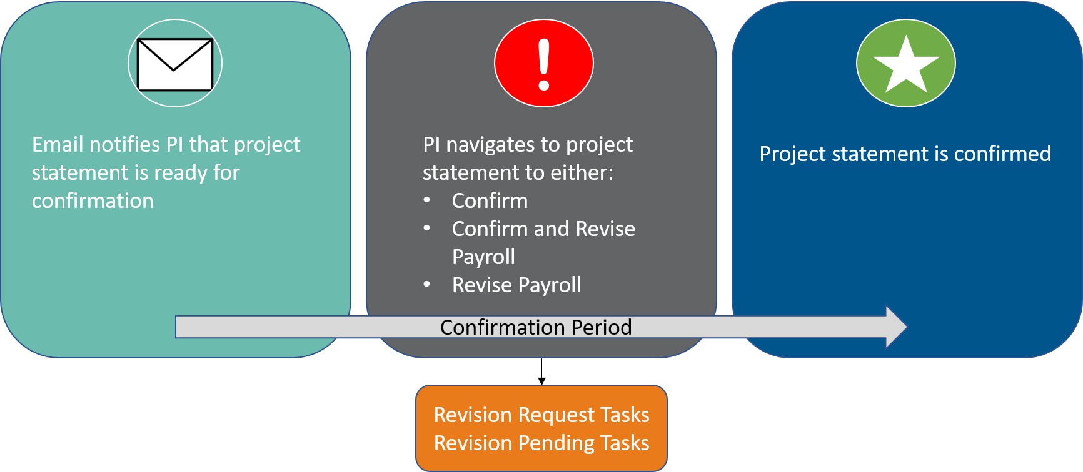
When the confirmation period begins, the Award PI (Confirmer) will receive a system-generated email notifying them that their project statements are ready for confirmation. The Primary Effort Coordinator will be copied on this email.
This is an example of a Confirmer notification email:
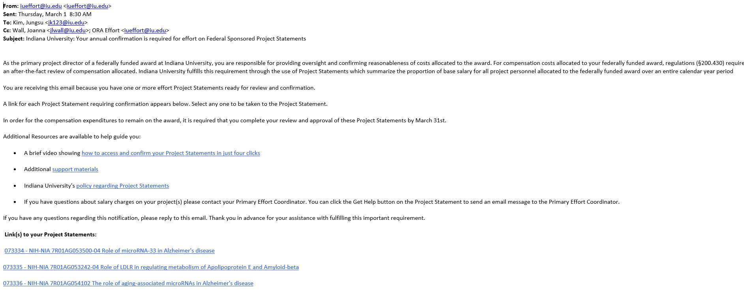
The Confirmer can click the project name hyperlink to navigate to the project statement in ECC.
The information in this guide focuses on options available to the Effort Coordinator. Information about reviewing project statements and the PI process for confirming them are covered in the “EConfirm (ECC) Confirmer Guide” available here.

ECC Project Statement Status
Project statements move from one status to another as they are confirmed or as revisions are requested and processed. Actions that change a project statement’s status are noted throughout this document and you can view the list of statuses at the end of this document.

The Work List
The Work List is automatically displayed after you log in to ECC. Your worklist must be blank by March 31st. Three tabs are displayed on the Work List page:
- Statements Awaiting Confirmation
- Coordinator Tasks
- Assigned Subactivities

Statements Awaiting Confirmation
The Statements Awaiting Confirmation tab displays all statements in Ready for Confirmation status that the Award PI (Confirmer) is responsible for confirming. This list is blank for Effort Coordinators as they are not required to confirm project statements.

Coordinator Tasks
The Coordinator Tasks tab displays revision tasks that need to be processed. These tasks result from a Confirmer requesting changes to their project statement, which in turn causes a revision task to be routed to all Effort Coordinators for that project’s Department. You may either approve or reject the requested changes. Detailed options for processing tasks are covered later in this guide.

Project Statements
If you are a Primary Effort Coordinator, the Project Statements tab displays all project statements for Award PIs (Confirmers) associated with your assigned departments. All these Project Statements must be completed by March 31st. This list includes statements that are in the following statuses:
- Ready for Confirmation
- Reopened, Not Confirmed
- Reopened by Payroll Adjustment, Needs Confirmation
Note: As each statement is confirmed, it is removed from the Project Statements tab.

Managing Project Statements
A project statement is created for any Award (KC Award Family) when an individual is directly charged or cost-shared to the project. The statement can be viewed at any time, either through the Department Dashboard or using the Search Box.
Please note that the Calendar Year Effort Project View report is available to ensure that the effort is being reasonably allocated to the project throughout the calendar year. The report displays summarized Institutional Base Salary payroll expenses and effort information by Award and Account PI for a given calendar year by Project or account. This report provides the same information as the PI will be required to confirm in March of every year in EConfirm (ECC).
View the Calendar Year Effort View Report

Finding a Project Statement
The Search Box is located in the upper right corner of the page. You can search for a project name, KC Award Family ID, Department code (Chart-Org), or department name (Organization Name), then click the Search button.
The system will filter all matching results based on the first three characters entered. If you continue typing and the system recognizes an exact match, you will be routed to the appropriate page.
If there is more than one match, you will be routed to a Look-Up Page where you can select your desired result from various possible matches.
Note: If you are a Primary Effort Coordinator, you can find a project statement and bypass navigating back to the Home Page by following these steps:
- Click Confirm from the top navigator.
- Click My Project Statements from the top sub-navigator.
- Select any PI name from the Work List to view that PI’s project statement(s).
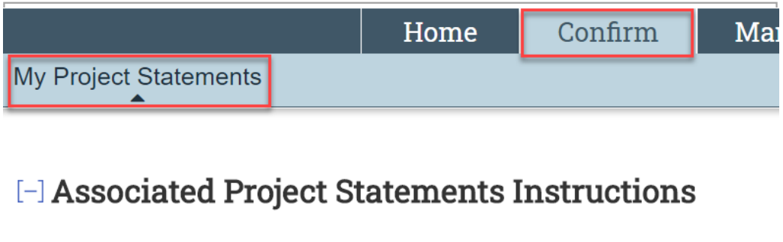

The Project Statement Page
Clicking a project statement link in the system-generated email you received or navigating within ECC as described above, you will be able to view project statement associated with the Department(s) for which you are an Effort Coordinator.
The Project Statement Page consists of three panes which provide information relevant to the confirmation process:
- Work List Summary Pane
- Statement Information Pane
- Project Statement Pane
At the bottom of the project statement, the following sections appear:
- Notes
- Attachments
- Transactions
- Activity Log
- Email Log
Note: A star icon indicates that there is content available to view in that section. Click the arrow ► to expand and view.

Work List Summary Pane
The top left pane displays the Work List which shows project statements associated with this Award PI (Confirmer) and other Confirmers with projects in the Department(s) you are associated with. Statements are grouped by status.
Click the arrow icon ► to expand and view the Confirmer’s project statements. The project statements will be grouped by status.
Click the arrow icon ► next to each status to view all of the Confirmer’s project statements in that status. By default, the Ready for Confirmation status section will be open. Ready for Confirmation statements represent your to-do list, statements that must be confirmed during the current confirmation period. Please note that the project statements in Building status do not require action.
The highlighted project is the one currently being viewed.

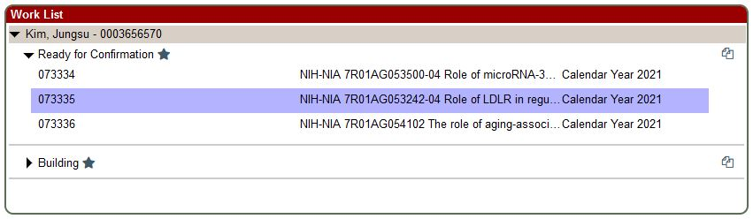
A star next to the status name indicates that there are project statements in that status.
The document icon in the upper-right corner () can be used to display multiple project statements at once. Clicking it will adjust the Project Statement Pane and Statement Information Pane (detailed below) to display all that Confirmer’s statements in the same status as the currently selected project statement. Click this icon again to go back to the single project statement view that is the default.

Statement Information Pane
The top right pane displays information about the project for the statement that is being highlighted.
This includes a list of account numbers, the lead Department (Chart-Organization Code), dates, title and other identifying information associated with the project.

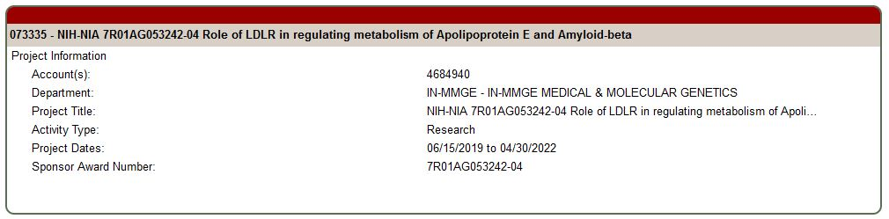

Project Statement Pane
The project statement pane lists all employees who were directly charged or cost-shared on the highlighted project during the calendar year listed.
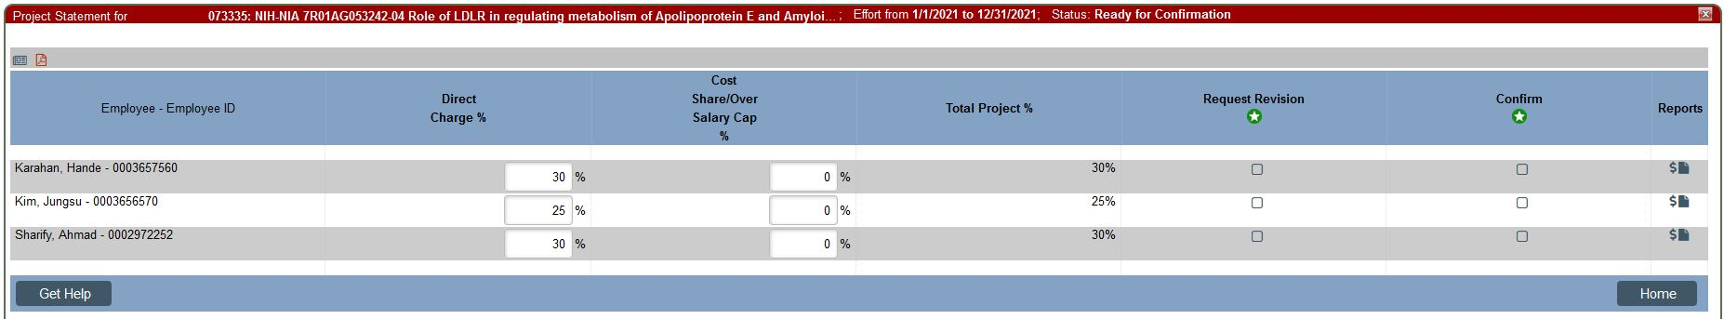
If you want to review payroll for a specific employee, click the document icon under the Reports column.
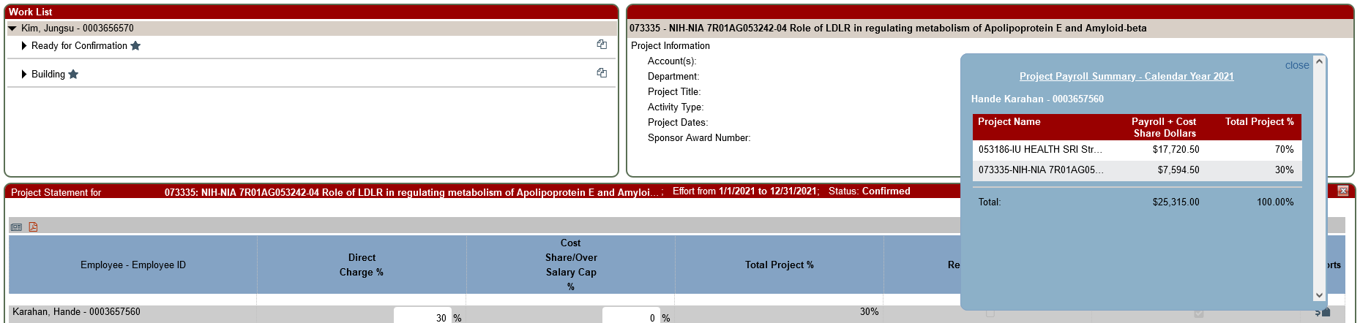
This pop-up will display the 100% allocation of payroll for the employee during the calendar year.
If you want further information you can drill down into the payroll transaction detail for the employee. Click the dollar sign icon under the Reports column.
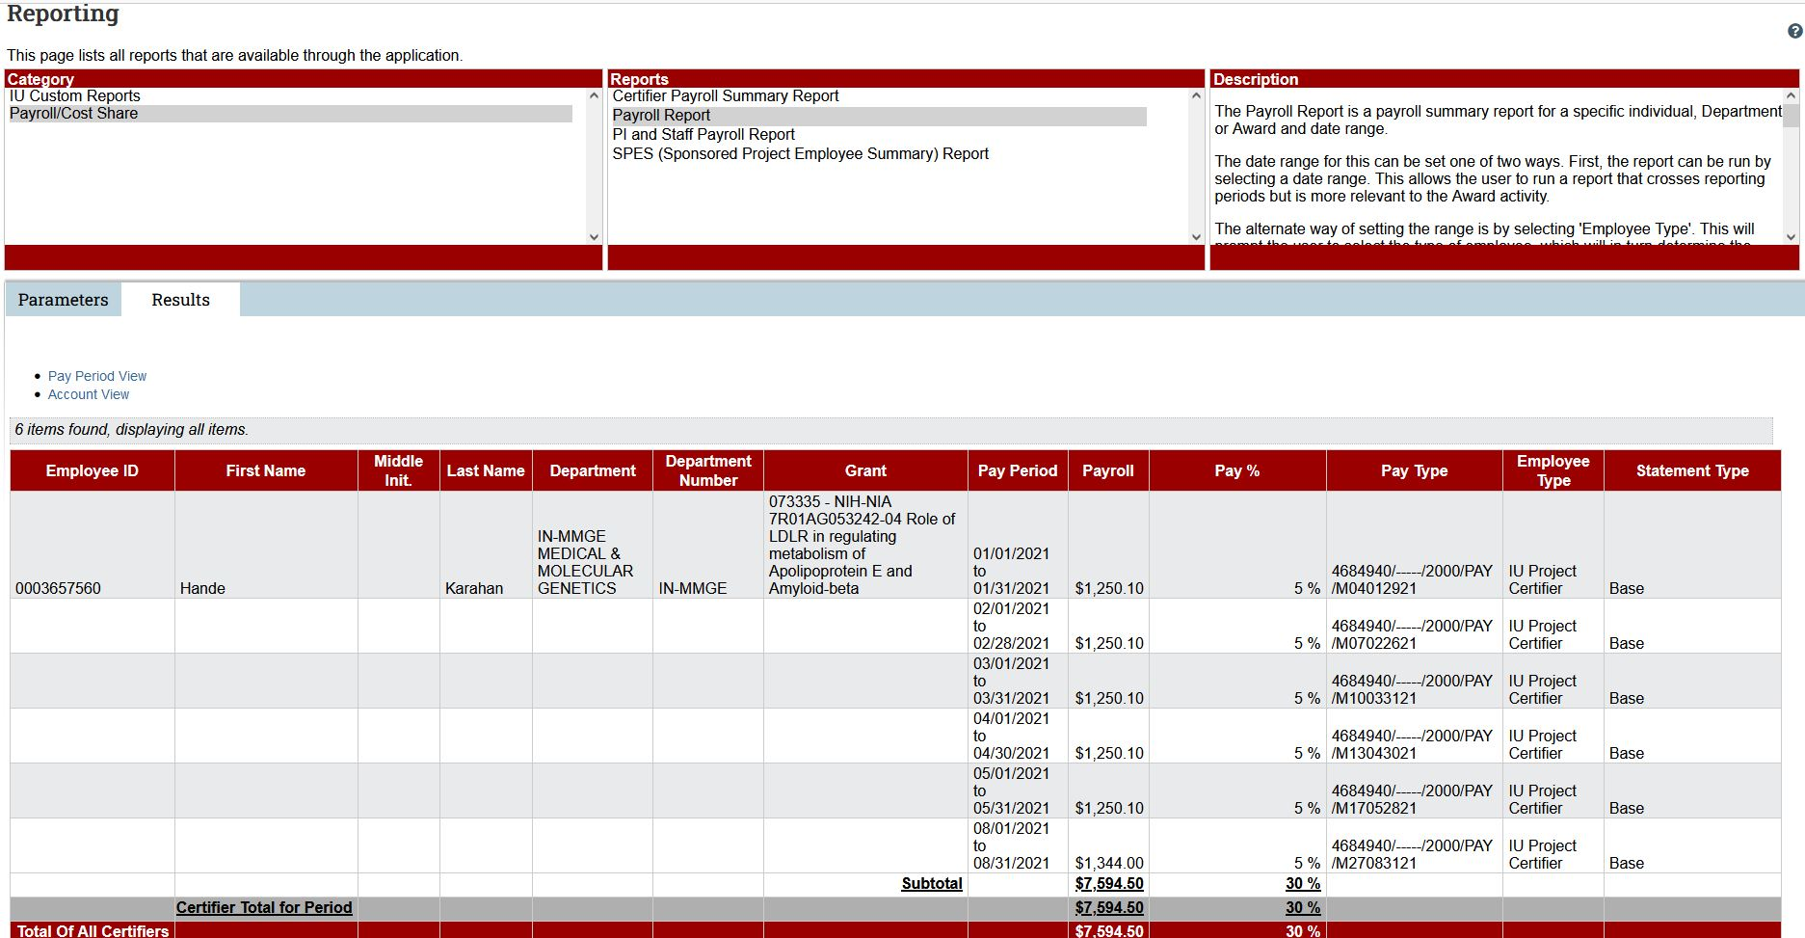
This will take you to a new screen which will display a report of all that employee’s payroll transactions for the year. This report can be exported to Excel for further analysis.
Note: ORA has developed several reports to assist you in management of payroll and project statement review. See the Reporting section of this document for a summary of the reports and links to them..

Project Statement Revision

Best Practice for Changing Project Statement Effort
If upon review of the project statement prior to confirmation the Confirmer identifies potential changes to the statement, Confirmers should take the following steps:
• Contact the Effort Coordinator to review the project statement
• If after consultation with the Effort Coordinator, there is a change required, the Effort Coordinator will complete the salary transfer (ST) to change the labor charges associated with the project statement revision.
• Please note that effort changes to project statements require salary cost transfers external to EConfirm (ECC). Transfers of expenditures to federal cost reimbursable awards where the cost transfer document is initiated more than three months after the month in which the cost was incurred will be a Late Cost Transfer. Cost transfers affecting a project statement in the confirmation period must be fully routed and approved by March 20th. See the policy, Cost Transfers on Cost Reimbursable Grants and Contracts for additional information

Project Statement Revision Requests in EConfirm
If the Award PI (Confirmer) selected either the Confirm and Revise Payroll or Revise Payroll buttons during the confirmation process, a revision requested task will be created for all Effort Coordinators. The project statement will not be available to the Award PI (Confirmer) until these revisions are completed
As an Effort Coordinator, your responsibility is to review and either reject or approve the requested labor revisions.
A Project Statement Revision Requested task will appear on the Home Page under the
Coordinator Tasks tab.
- To process a Project Statement Revision Requested task:
  - Click the hyperlink for Project Statement Revision Requested.
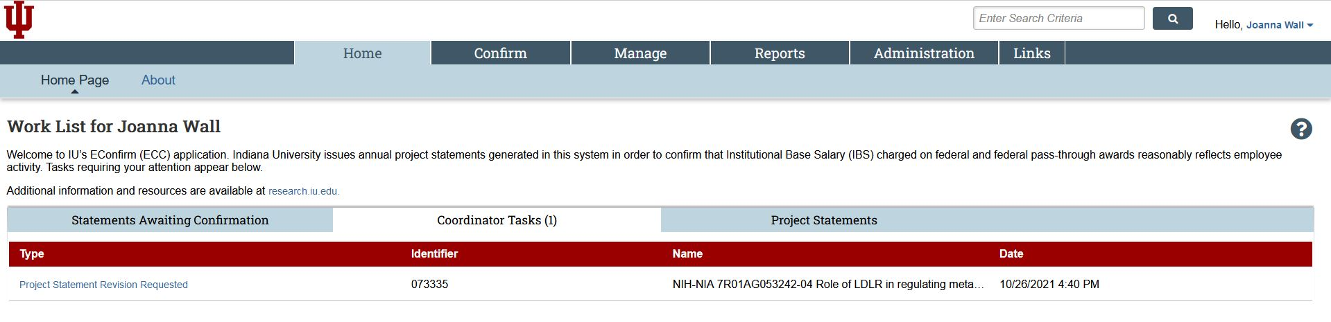
  - Review the percentages in the Direct Charge % and Cost Share/Over Salary Cap % columns and compare them to those shown in the Previous Payroll and Previous Cost Share columns. Please validate that these are the correct allocations to the award.
Award PIs (Confirmers) are not required to change percentages on the project statement when they request a revision. If you are uncertain of the revision being requested by the Award PI (Confirmer), consult with them before approving or rejecting the Revision Requested Task.
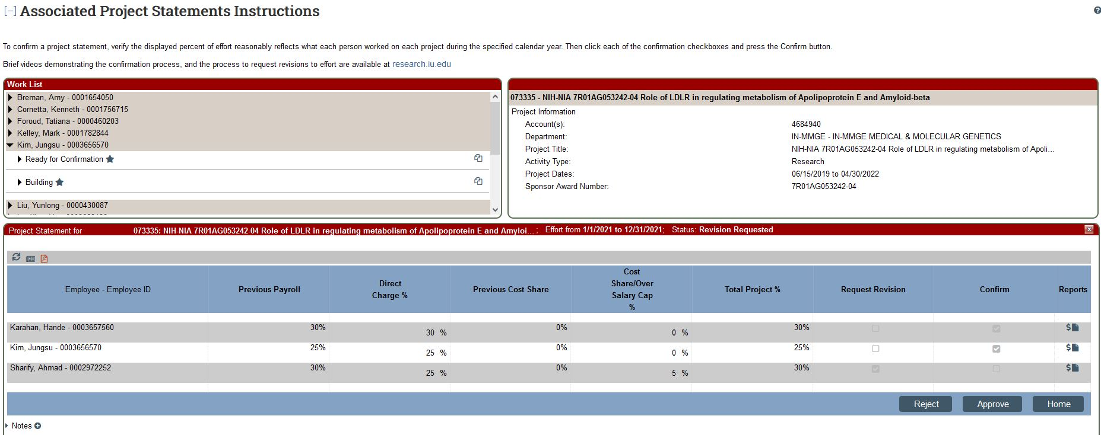
  - Determine whether you wish to approve or reject the revision made by the Award PI (Confirmer):
    - If a payroll revision is not necessary, click Reject. The statement returns to the Ready for Confirmation status, and appears on the Award PI’s (Confirmer’s) Work List. Without any changes to the confirmation statement.
Note: You should notify the Award PI (Confirmer) that the statement has returned to the Ready for Confirmation status as the Confirmer will not receive a notification of this status change.
    - If a revision is necessary, click Approve. The project statement remains in Revision Requested status. Next, you will need to create a Salary Expense Transfer document to perform the labor adjustment in KFS.
Note: Transfers of expenditures to federal cost reimbursable awards where the cost transfer document is initiated more than three months after the month in which the cost was incurred will be deemed a Late Cost Transfer. Cost transfers affecting a project statement in the confirmation period must be routed and fully approved by March 20th. See the policy, Cost Transfers on Cost Reimbursable Grants and Contracts, for additional information on requesting an exception in this case. Workflow diagrams showing the process flow, including salary transfers, are available in Appendix D: Project Statement Workflows.
Once the Revision Requested task has been either rejected or approved, it is automatically removed from the Coordinator Tasks tab. The Award PI (Confirmer) will be unable to make any additional changes to the statement until it returns to Ready for Confirmation status.
Important: Labor adjustments are not made in ECC. All payroll adjustments must be made in KFS. The adjustments will then be uploaded into ECC when the KFS document is fully approved and processed during the nightly KFS batch. Note this batch process does not run on Saturdays unless it is the last day of a calendar month.

Process Project Statement Revision
When labor adjustments are loaded into ECC for a statement currently in Revision Requested status, a Revision Pending task will be created for all Effort Coordinators and the impacted project statements will be moved to the Revision Pending status.
As an Effort Coordinator, you are responsible for ensuring the Salary Transfer needed gets initiated and for reviewing and verifying that the adjusted payroll for each employee is now reasonably allocated.
- To process a revision pending task:
  - Click the hyperlink for the Process Project Statement Revision task from the Coordinator Tasks tab.
  - Review the new payroll information for accuracy. The New Total Project % includes the payroll adjustment that was made for that project in that calendar year after the salary transfer has been completed.
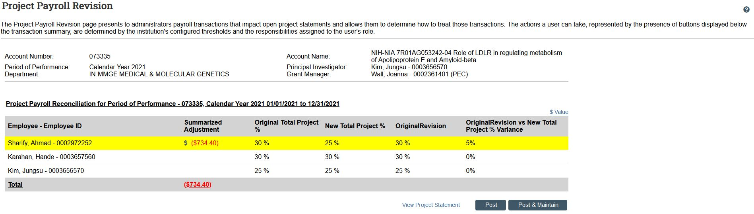
  - If the employee name is highlighted, new labor entries (ST) have been loaded for that employee for this project.
The ‘Summarized Adjustment’ column shows the net dollar change from these labor changes.
The ‘Original Total Project %’ shows the total project percentage for that employee prior to the PI’s requested revision.
The ‘New Total Project %’ shows the current revised total project percentage with these labor changes applied. This is the % that will be confirmed.
The ‘Revised % Request’ column shows the requested percentage entered by the Award PI (Confirmer) when they entered the revision. Remember, Confirmers are not required to enter an updated percentage value when requesting a revision. In these cases the ‘Revised % Request’ would match the ‘Original Total Project %.’
The ‘Revised % Request vs New Total Project %’ Variance subtracts the ‘Revised % Request’ from the ‘New Total Project %’ and shows the difference, if any. This tells you how close the current labor adjustment being reviewed puts you to matching the ‘Revised % Request.’ If the difference is less than 2% the salary has been reasonable allocated and you can post and confirm.
Use the “$ Value” link to toggle to a dollars-only view.
  - Determine how you wish to process the revision:
    - Click Post if the the New Total Project % on the Revision Pending task reasonably reflects the payroll for the employee, for the project, for the calendar year. The payroll updates on the project statement when you choose Post and the Task is removed from your Coordinator Tasks tab. The statement will automatically change to Ready for Confirmation status, the task will disappear from your task list and will appear on the PI's Work List.
    - Click Post & Maintain if the the New Total Project % on the Revision pending task does not reasonably reflect the payroll for the employee, for the project, for the calendar year and additional adjustment (ST) is needed. The current ST displayed on the task will post to the project statement and the Task will be removed from your Coordinator Tasks tab, but the statement will remain in the Revision Requested status and will not go back to the PI. The Effort Coordinator must resolve the variance.
************************************************************************************************************

Reports and Resources
Several reports exist to help you manage your payroll throughout the calendar year. Using these reports throughout the calendar year is strongly encouraged as they can help ensure that effort is reasonably allocated when the confirmation period begins.

Calendar Year Effort View
This dashboard report is available via the ORA Departmental Management Dashboards tile, within One.iu.edu.
The report displays summarized Institutional Base Salary payroll expenses and percent of effort information by Award and Account PI for a given calendar year by Project (Award family) or Account. A single person view is also available showing calendar year and month distributions of effort for that employee.
Effort data in ECC is aggregated into Project Statements at the Project level and requires confirmation by the Project’s overall Award PI. This report takes the same information used to populate ECC and allows you to see it at a more granular level—specifically by Account and Account PI. Filters at the top of the report allow you to limit results to a particular Calendar Year, Award PI, Account PI, Project or Account Number. By default, only Federal of Fed Pass-Through projects are displayed but the “Funding Source” filter can be used to also select Non-Federal projects. Note that effort confirmation is not required for Non-Federal projects, so Project Statements are generated for these Projects but those statements are auto-approved by ECC at the start of the confirmation period.
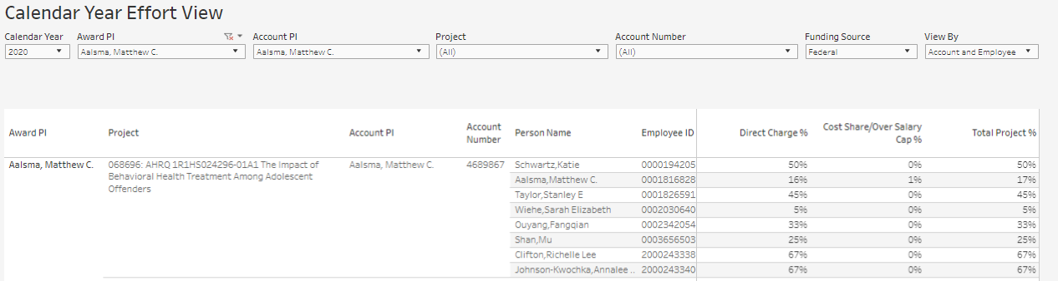
Hovering your cursor over a percentage will display additional tooltip information, including that employee’s year-to-date IBS for the calendar year being displayed. Note that percents are shown as whole numbers on the report, consistent with how they are displayed in ECC. When hovering over a number you can see the associated dollar amount and the percentage it represents out to the tenth of a percent.
The Single Employee Effort View is available on another tab of this report and displays effort distribution for a single selected employee by calendar year and month. Effort is displayed by Project by default, but a view by account/sub-account can be selected using the Show By drop-down.
A Graph and table display effort information by calendar year, while a table at the bottom of the dashboard displays effort information by calendar year and month.
Hovering over data points (bars on the bar graph or numbers on the tables) will also display additional tooltip information, including the associated dollar amount, IBS total for the year displayed and the associated percent of effort to the tenth of a percent.

Institutional Base Salary Payroll
This dashboard report is available via the ORA Departmental Management Dashboards tile, within One.iu.edu.
The report displays summarized Institutional Base Salary payroll expenses and percent of effort information by person, award family, and account/sub-account for selected fiscal year and periods. Results can be filtered by many attributes including Account Number, Employee Name, Principal Investigator, and Fund Group.
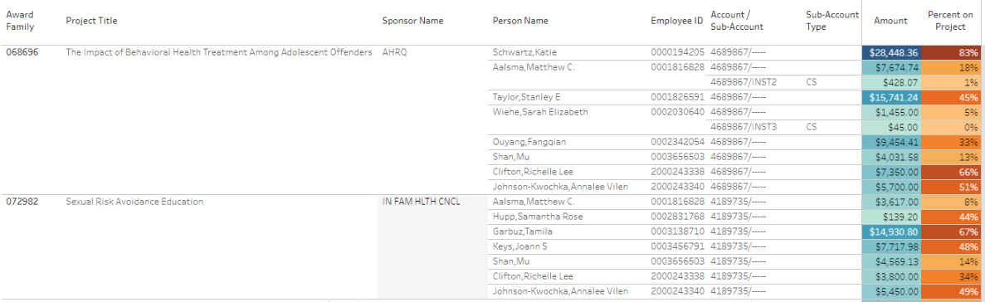
A total IBS salary amount for that period, Project and account/sub-account is shown along with the percent of overall salary for the selected period this amount represents. Hovering over a salary amount or percentage will display the overall salary for the selected period.
A second tab, By Period, is available and shows the same information but broken down by each fiscal period in the range of periods you have selected.
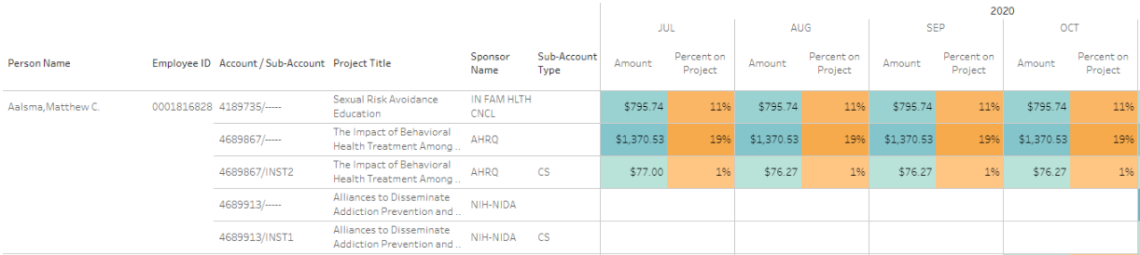
An effort amount and percent on project are displayed for each month in the view. Hovering over the amount or percentage will display the overall salary for that given month.

Other Dashboard Reports

Expiring Accounts with Labor
Provides information regarding salary paid for employees on expiring accounts. The report may be filtered to provide information by organization, accounts or individuals.
View the Expiring Accounts with Labor Report

Salary Charged to Grants
Displays summarized salary information by fiscal year and various funding categories (Non-Contract & Grant, Contract & Grant, Cost Share etc.). Provides a list of employees associated with a given Responsibility Center or Organization, their salary and funding source. Also provides detailed salary information for selected individuals breaking down their salary charged across specific accounts or fund groups.
View the Salary Charged to Grants Report

Labor on Continuation Accounts
Displays labor detail that was originally intended to post to a Contract & Grant account that posted to a non-C&G continuation account instead.
View the Labor on Continuation Accounts Report

Reports within ECC
ECC also provides several reports to assist you in monitoring the confirmation period.
Tip: You can download your results in different file formats. Your file format options are displayed in the Results tab below the report data. To export your report for use in Microsoft Excel, select the Excel export option.
Depending on the report, you may have some or all of the parameter options available:

Parameter Options
Button/Field | Function
Arrow Button | Select your parameter, then use the arrow button to move your parameter from left to right to add, or from right to left to remove.
Double Arrow Button | Move all parameter options from one panel to the other.
Text Search Field | Begin by typing at least three letters of your desired search term. Matching results will be displayed as you continue typing. Select the value you want when you see it displayed.  For some searches you may be able to further refine your search by clicking Expand Search.
Check Box | Select multiple parameters or items.
Radio Buttons | Select one item.
Date Picker Button | Select a date. You can click a date from the picker or type a date in the field.
Informational Button | Click to get more information about any parameter. Click again to close the hover information.
  Drop-down Menu | Select an option from the list.
Blank Field | If a field entry is not required, the field can be left blank. Leaving the field blank will act as a wild card, which will include all possible results. This can cause reports to be very large and take more time to generate.
- To access reports:
  - Click Reports from the top navigator.
  - Click Reporting from the top sub-navigator.

Project Status Report
The Project Status Report shows a list of all project statements that have a specified status at the time the report is run.
- To run the Project Status Report:
  - Select the Management category.
  - Select the Project Status Report.
  - Set your desired report parameters in the Parameters tab.
    - Select your desired statuses and move them to the right using the arrow button.
    - You can specify a PI by entering the PI's name in the PI field. Select the PI name you want when you see it displayed.
    - You can specify a department or school by entering the department name or Chart-Org code in the Department field. Select the Department you want when you see it displayed.
    - The Date By field allows you to either limit your results by Dates (you will enter a start and end date) or Employee Type. Note that the only valid Employee Type in ECC is ‘IU.’ If you select Employee Type you must also select a Period (this corresponds to the valid calendar year).
  - Once your parameters are set, click the Run Report button.
  - You may receive an error indicating that your report contains no data. To resolve this, re-check your parameters or widen your search criteria, then click Run Report again.
  - Your report is displayed in the Results tab.
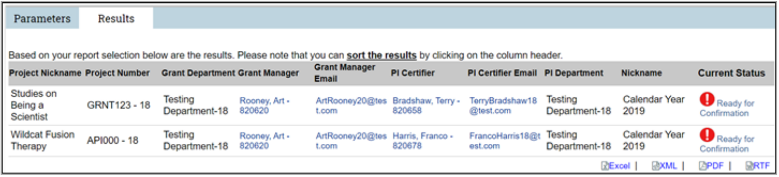
You can click the status name in the Current Status column to go directly to the project statement.

PI and Staff Payroll Report
This report generates a list of all individuals with labor charges associated with a PI's projects, and shows their monthly effort percentage distributions on each of those projects. The cost share column will be populated with the word True to indicate that at least one payroll transaction on that sponsored project is identified as cost share.
- To run the PI and Staff Payroll Report:
  - Select the Payroll/Cost Share category.
  - Select the PI and Staff Payroll Report.
  - Enter your parameters.
    - You can specify a PI by entering the PI's name in the PI field. Select the PI name you want when you see it displayed.
    - You can leave Search by Statement Type defaulted to ‘Base’ as this is the only statement type IU uses.
    - The Date By field allows you to either limit your results by Dates (you will enter a start and end date) or Employee Type. Note that the only valid Employee Type in ECC is ‘IU.’ If you select Employee Type you must also select a Period (this corresponds to the valid calendar year).
  - Click Run Report.
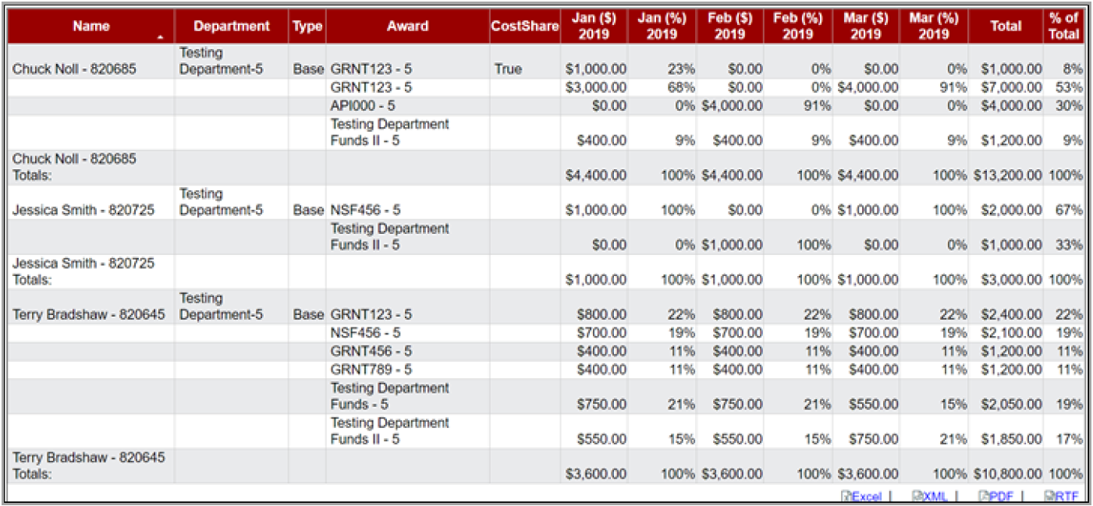

Sponsored Project Employee Summary (SPES) Report
The SPES Report lists all employees that charged payroll or cost share to a specific project.
- To run the SPES Report:
  - Select the Payroll/Cost Share category.
  - Select the SPES Summary Report.
  - Enter your parameters.
    - In the Account field enter the award family ID of the project you wish to report on. If you cannot locate the project, try setting the active/inactive radio button to ‘inactive’ and search again.
    - The Date By field allows you to either limit your results by Dates (you will enter a start and end date) or Employee Type. Note that the only valid Employee Type in ECC is ‘IU.’ If you select Employee Type you must also select a Period (this corresponds to the valid calendar year).
  - Click Run Report.
Note: If the date range selected spans more than one calendar year, an employee may be listed twice. Each row represents a different calendar year.
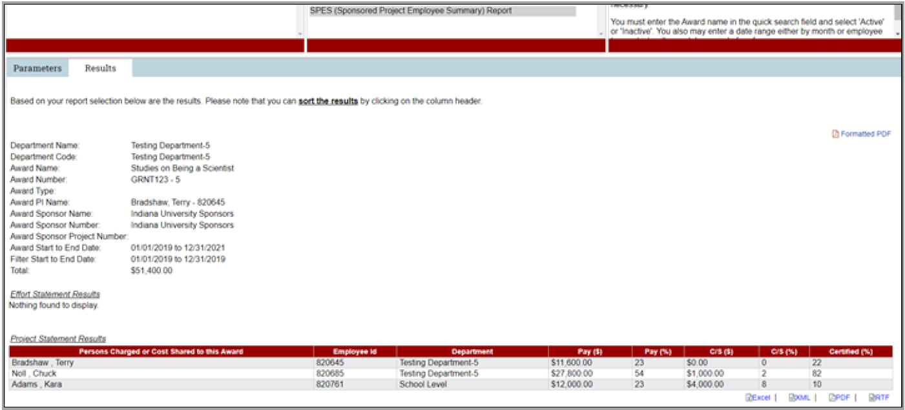
************************************************************************************************************

Appendix A: Maintenance of Effort Coordinators
ECC Effort Coordinators are assigned and maintained based on Fiscal Officer and Delegate roles in KFS. ECC Effort Coordinators exist at the Department level while KFS Delegates and Fiscal Officers exist at the Account level. So some mapping is required to populate Effort Coordinators based on KFS data.

To Add an Effort Coordinator
After the initial population of Effort Coordinators, to add an Effort Coordinator for a Department:
- Add an ECD delegate to any CG account associated with this Department.
  - Using the Account Delegate or Account Delegate Global document in KFS, add a delegate of document type ECD (primary or secondary). This will add that person as an Effort Coordinator for the Department associated with that account.
  - If there are no ECD delegates on this account, adding a delegate of document type KFS (primary or secondary) will also add that person as an Effort Coordinator for the associated Department.
Note: Adding delegates as ‘primary’ in KFS will change the routing of related KFS documents. Adding a secondary delegate gives that user the ability to go find and take action on documents they are a delegate for, but will not change the normal routing of those documents.
- As new grant accounts are added to KFS, the Fiscal Officer for those accounts is added as an Effort Coordinator for the associated Department.

To Change an Effort Coordinator
Grant account changes in KFS that update Account Delegates or Fiscal Officers on existing accounts will automatically update Effort Coordinators in the associated Departments. These include:
- Updating KFS delegates for document types ECD on an account (or document type KFS if there are no ECD document type delegates on that account), using either the Account Delegate or Account Delegate Global documents.
- Changing the Fiscal Officer associated with a grant account using the Account or Account Global document.
See information below for changing which Effort Coordinator is designated as the Primary Effort Coordinator for your Department.

Changing Primary Effort Coordinators
- Effort Coordinators in ECC have permission to make another existing Effort Coordinator in their Department ‘Primary.’ Effort Coordinators can manage this distinction themselves within ECC. Information on how to assign a Primary Effort Coordinator for a Department is covered later in this document.
- System administrators will also have the ability to change Primary Effort Coordinators if needed. If you feel you need assistance with Effort Coordinator assignments, please contact iueffort@iu.edu.

To Remove an Effort Coordinator
- If the Effort Coordinator you wish to remove is the Primary Effort Coordinator for the Department, you must first select a different person to assume the Primary Effort Coordinator role as described above. ECC will prevent KFS from removing someone still identified as a Primary Effort Coordinator.
- Use the Account Delegate or Account Delegate Global document to inactivate that user’s ECD and/or KFS document type delegations on all grant accounts associated with this Department.
- Use the Account or Account Global document to remove this user as a Fiscal Officer for any grant account associated with this Department.
A video guide explaining how Effort Coordinators are populated in EConfirm (ECC) and how to assign a Primary Effort Coordinator in EConfirm (ECC) is provided below.
Assigning Effort Coordinators Video

Appendix B: Project Workflow Statuses
The following is a list of the workflow statuses you may see when working with project statements.
Status | Icon | Description
Building |  | This status indicates that a project statement is not yet ready for confirmation. This occurs during the calendar year, when payroll and profile data are being loaded and the project statements are building.
Auto Approved |  | This status is for non-federal project statements that are auto approved. The system automatically moves project statements that have no federally sponsored payroll or cost share associated with them into this status when the confirmation period begins.
Ready for Confirmation |  | This status indicates that the project statement is ready to be confirmed. Statements move to this status when the Confirmation Period begins, and the statement requires the PI to confirm the payroll charges for the period.
Revision Requested |  | During the Confirmation Period, after a PI clicks the Revise Payroll checkbox and inputs a payroll and/or cost share percentage, they click the Revise Payroll button which moves the statement to this status.
Revision Pending |  | When new payroll loads to a statement in Revision Requested status and creates a payroll task that will be processed by the Effort Coordinator, that statement moves to this status.
Confirmed |  | This status indicates that every individual on this project statement has been confirmed.
Confirmed, Payroll Pending |  | This status indicates that an individual confirmed their project statement and a payroll transaction occurred after the fact.  The payroll transaction creates a Payroll Reconciliation (PAR) task and the project statement remains in this status until an administrator completes the PAR task.
Manually Confirmed |  | This status indicates a project statement has been marked as Manual Confirmation. This is an exceptional status that can only be set by system administrators.
Manually Confirmed, Payroll Pending |  | Indicates a project statement has been marked as Manually Confirmed and an additional payroll transaction has been loaded to this project statement, creating a PAR task. The project statement remains in this status until an administrator completes the PAR task.
No Confirmation Required |  | Indicates a project statement has been marked as No Confirmation Required. This is an exceptional status that can only be set by system administrators.
No Confirmation Required, Payroll Pending |  | This status is when a project statement has been marked as No Certification Required and an additional payroll transaction has been loaded to this project statement, creating a PAR task. The project statement remains in this status until an administrator completes the PAR task.
Re-Opened, Not Confirmed |  | This is the status of a project statement that has been re- opened, and the statement needs to be re-confirmed by the individual.
Reopened by Payroll Adjustment, Needs Confirmation |  | This is the status of a project statement where a payroll transaction was applied, and the statement needs to be re- confirmed by the PI due to changes in the payroll percentages on the project statement.

Appendix C: How Does IU Define Institutional Base Pay?
Institutional Base Salary (IBS): The base annual salary received for a payroll appointment. At Indiana University this is defined as base pay applicable to an appointment. This includes, if appropriate, compensation from both Indiana University and an Approved Practice Plan. IBS does not include overload or supplemental payments. Additional information regarding IBS may be found on the ORA webpage How IU defines Institutional base salary (IBS).

Appendix D: Project Statement Workflows
BEST PRACTICE REVISIONS
PROJECT STATEMENT WORKFLOW
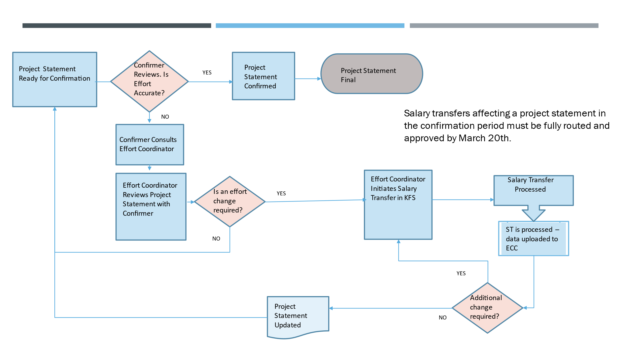
Econfirm Initiated Revisions –
Project Statement Workflow
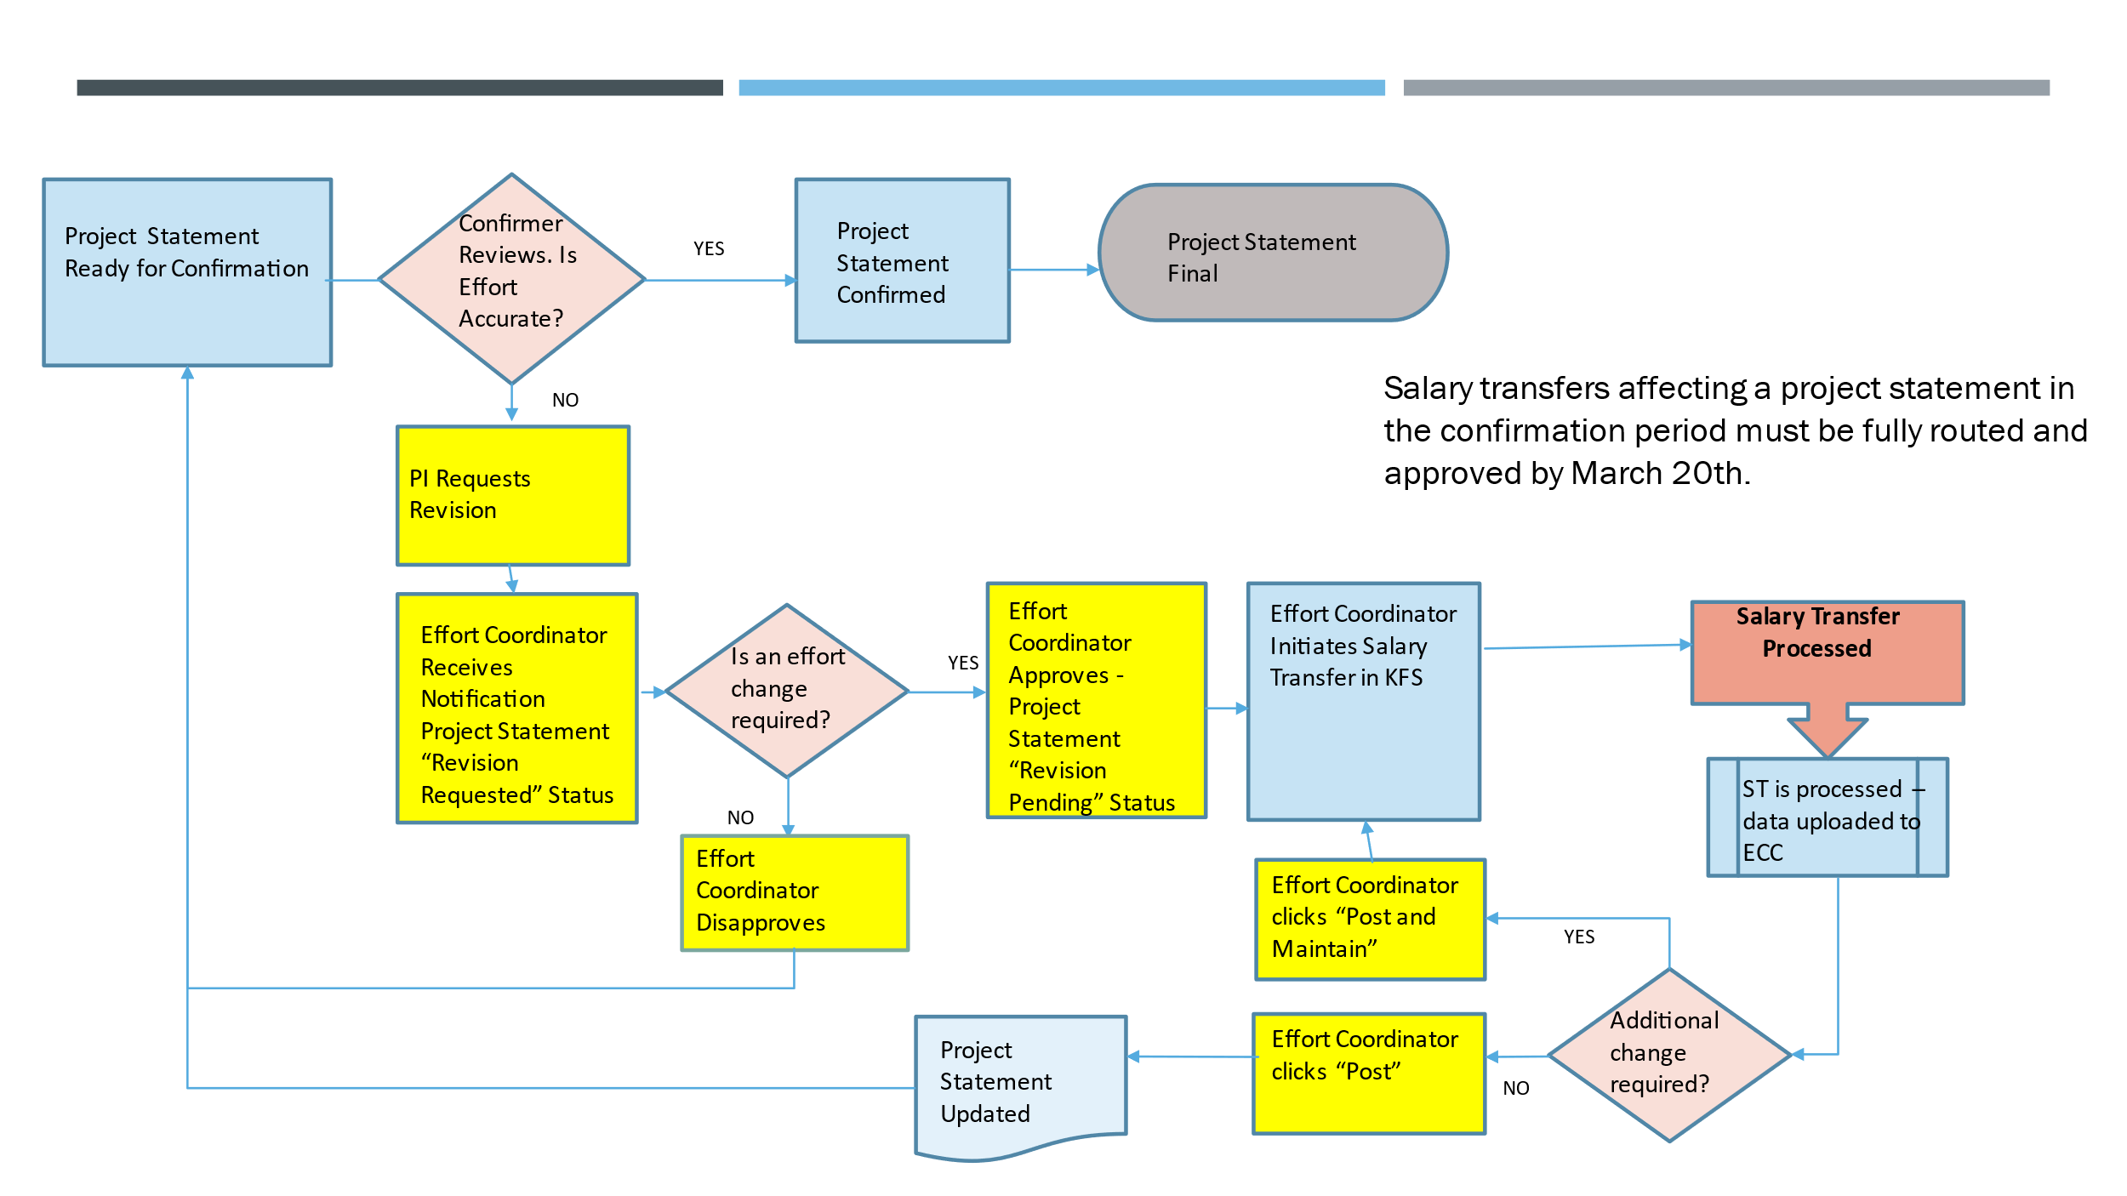

Appendix E: Using the Department Dashboard
As a Effort Coordinator, you can view and manage information related to a department including the projects, awards, and other effort coordinators associated with that department, using the Department Dashboard.
- To navigate to the Department Dashboard:
  - Click Manage from the top navigator.
  - Click Department Dashboard from the top sub-navigator.
  - Using the dropdown menu, select the desired department and click Choose.
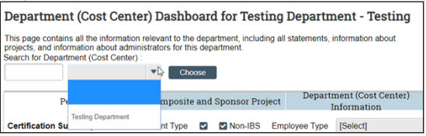
  - Click the Project Confirmations tab.
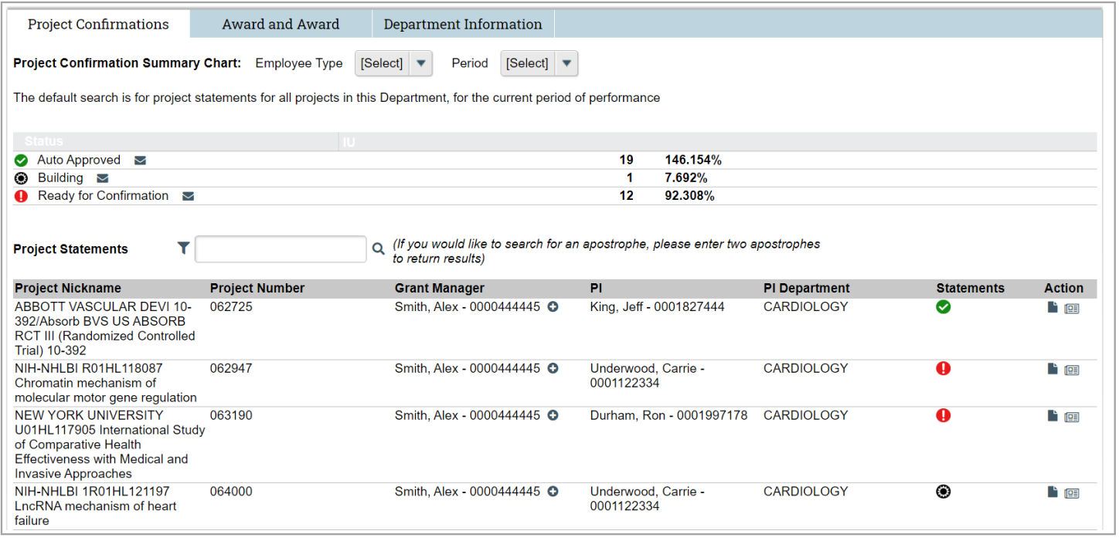

Confirmation Summary Chart
The Confirmation Summary Chart displays statistics for the most recent calendar year.
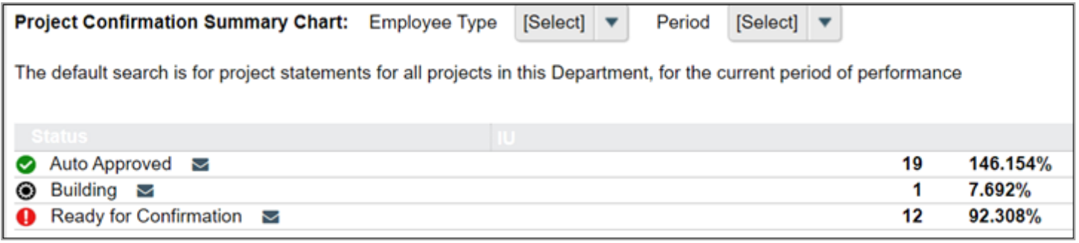

Project Statements by Department
Below the Confirmation Summary are listed all project statements associated with the department. This list includes all historical and current statements.
Tip: Click any statement icon in the Statements column to navigate to that project statement. Hover over a statement icon to view the calendar year for the project statement.
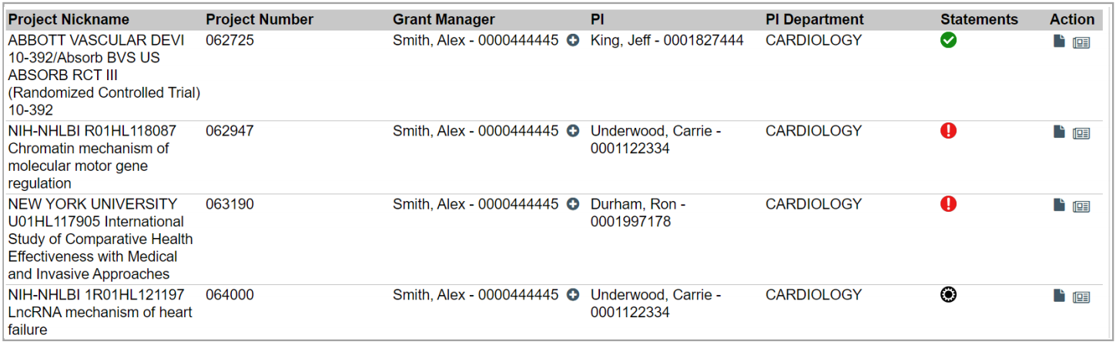

Award and Award Tab
The Award and Award tab contains all of the awards and accounts that are assigned to the department, whether active or inactive, in a single list.
An active status indicates the project's end date is after the current date.
An inactive status indicates the project's end date is before the current date.
Tip: The inactive icon () will appear next to any award where the end date is prior to the current date. This is informational and has no impact on the confirmation process.
The list displays the Award Number (KC Award Family ID), associated KFS Account Number, name, sponsor and PI of the award, and the start and end dates. Note that Awards with multiple accounts will appear multiple times on this list, once for each account.
Account information is provided for ease of reference but project statements summarize activity at the Award Number (KC Award Family ID) level.
- To navigate to an Award Summary page:
  - Click the desired project name.

Award Summary Page
Each award/account combination has a summary page that displays the following information about the project:
- Award Name
- Account Number
- Sponsor name and sponsor number
- PI
- Start and end date
- Account Manager (the Primary Effort Coordinator) associated with this project

Award Summary Examples
The Account Summary Page displays additional information about the associated award. The Award Name value is a link to the related, overarching Award Summary page. In this example, we'll click the hyperlink next to the award name to navigate to that Award Summary page.
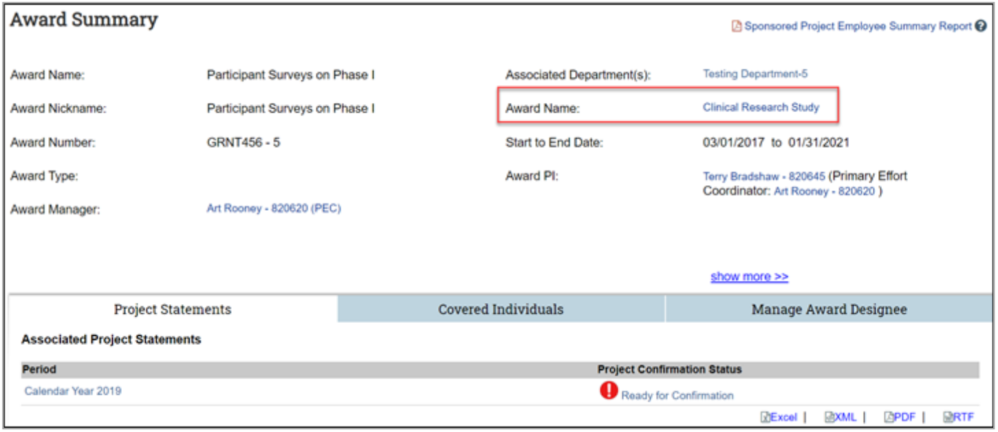
The Award Summary Page displays reference information about the award itself and shows a list of associated Project Statements.
The Covered Individuals and Award Designee tabs are displayed below the project information.

Covered Individuals Tab
This tab lists all individuals that have payroll or cost share on the project. This list also includes the PI of the award.

Manage Award Designee Tab
This tab lists all projects related to an award. This is also where any designee relationships are displayed. Designees are individuals other than the Award PI that have been authorized, as an exception to standard procedure, to approve a project statement. The Account Designee function is restricted and requires senior level ORA approval and will require an email seeking approval to iueffort@iu.edu.

Department Information Tab
The Department Information tab contains information about the department’s Effort Coordinators. The Primary Effort Coordinator is highlighted in yellow; secondary coordinators are listed without highlighting. There can be only one Primary Effort Coordinator in a department at a time.
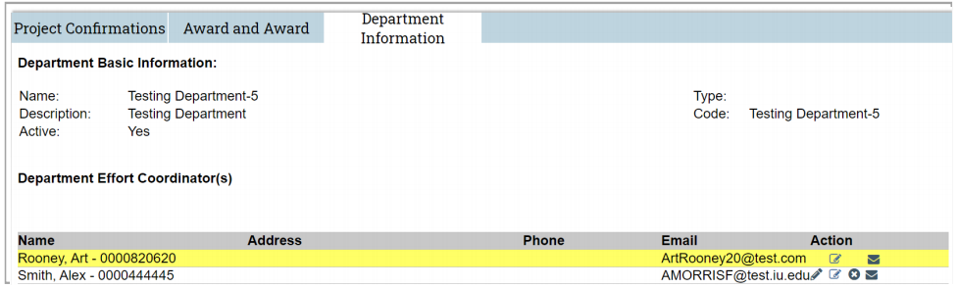
In this example, Art Rooney is the current Primary Effort Coordinator.
- To assign a Primary Effort Coordinator:
  - Click the Make effort coordinator primary icon in the Action column for the desired employee.
Note: Any effort coordinator associated with that Department can reassign the Primary Effort Coordinator designation to another Effort Coordinator in that Department.
For information on maintaining the list of Effort Coordinators associated with a Department, see Appendix A: Maintenance of Effort Coordinators.
© 2020 Huron Consulting Group Inc. and affiliates. All rights reserved. Use and distribution without a current software license from Huron are prohibited.
All trademarks, registered trademarks, service marks, and trade names are the property of their respective owners.
Information in this document is subject to change without notice. Published by Huron Consulting Group Inc.
9170 NE Turing Court
Suite 100
Hillsboro, OR 97006

